**CME 2201 - Assignment 2**

**GRAPH CENTRALITY METRICS**

In the scope of this project, you are expected to implement the Betweenness and Closeness centrality metrics and rank the nodes of the given two graph datasets which are Zachary Karate Club Network and Facebook Social Network.

**Explanation of Centrality Metrics**

Centrality metrics are used to identify the most important nodes within a graph. There are various centrality metrics including Degree, Closeness, Betweenness, Eigenvector, Katz, PageRank, etc. In the scope of this project, you are expected to implement the following two centrality metrics and test on the given two graph datasets.

1. **Betweenness Centrality**

Betweenness centrality shows the strategic location of a node in a graph. Betweenness centrality of a node *n* is defined as the number of shortest paths going through the node *n*. For each pair of nodes, shortest paths between them are computed and the fraction of shortest paths passing through *n* is calculated. The betweenness of node *n* is obtained by summing this fraction for all pairs of nodes as defined in the following equation.

$C_{B}\left(n\right)=\sum_{s≠n≠t∈V}{\frac{σ_{st}(n)}{σ_{st}}}$ $LR\left(n\right)=\frac{\sum_{deg∈DEG}{\left|sp(n, deg,G)\right|}}{\left|DEG\right|}$

where, $σ_{st}$ is the total number of shortest paths from node *s* to node *t*; $σ_{st}(n)$ is the number of those paths that pass-through node *n*.

1. **Closeness Centrality**

Closeness centrality depends on measure of how close a node is to the other nodes in the graph. A node in a more central location is considered closer to all other nodes. Closeness is calculated by taking the average length of the shortest paths between the node *n* and all other nodes as given in the following equation.

$C_{C}\left(n\right)=\frac{1}{\sum_{i≠n∈V}{dist(i,n)}}$ $LR\left(n\right)=\frac{\sum_{deg∈DEG}{\left|sp(n, deg,G)\right|}}{\left|DEG\right|}$

where *dist(i, n)* is the minimum distance between nodes *i* and *n*.

**GRAPH DATASETS**

1. **Zachary Karate Club Network**

The dataset contains social ties among the members of a university karate club collected by Wayne Zachary in 1977.

|  |  |  |  |
| --- | --- | --- | --- |
| # of Nodes | # of Edges | Format | Edge weights |
| 34 | 78 | Undirected | Unweighted |

1. **Facebook Social Network**

This social friendship network extracted from Facebook consists of people (nodes) with edges representing friendship ties.

|  |  |  |  |
| --- | --- | --- | --- |
| # of Nodes | # of Edges | Format | Edge weights |
| 1518 | 32988 | Undirected | Unweighted |

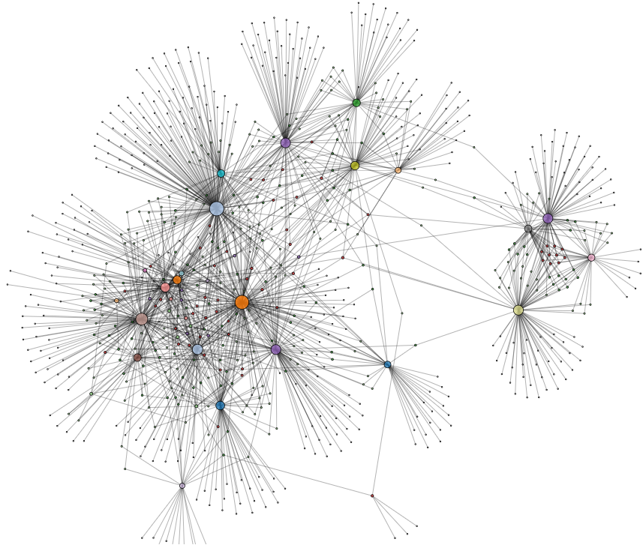

**Provided Resources**

Zachary Karate Club Network as edge list (karate_club_network.txt)

Facebook Social Network as edge list (facebook_social_network.txt)

**Due date**

**30.12.2021** Sunday 23:55. Late submissions are not allowed.

**Requirements**

• You need to implement base functions of a classical graph data structure and classes (do not extend an available Java Graph classes directly).

• Object Oriented Programming (OOP) principles must be applied.

• Exception handling must be used when it is needed.

**Submission**

You must upload your all ‘.java’ files as an archive file (.zip or .rar). Your archived file should be named as ‘studentnumber_name_surname.rar.zip’, e.g., 2007510011_Ali_Yılmaz.rar and it should be uploaded in the SAKAI portal. You can ask your questions from the “FORUM -> Homework 2 - Questions” part of the SAKAI portal.

**Plagiarism Control**

The submissions will be checked for code similarity. Copy assignments will be graded as zero, and they will be announced in the SAKAI portal.

***Your codes may be checked by automatic control. For this reason, the default print requirements are as follows when sending the code:***

StudentID Name Surname:

Zachary Karate Club Network – The Highest Node for Betweennes and the value

Zachary Karate Club Network – The Highest Node for Closeness and the value

Facebook Social Network - The Highest Node for Betweennes and the value

Facebook Social Network - The Highest Node for Closeness and the value

**Grading Policy**

|  |  |
| --- | --- |
| **Job** | **Percentage** |
| Graph Data Structure and Classes | %20 |
| Betweenness Centrality | %35 |
| Closeness Centrality | %35 |
| Print of Results for the Highest Nodes | %10 |

**References**

1. Rossi, R., & Ahmed, N. (2015, March). The network data repository with interactive graph analytics and visualization. In Twenty-Ninth AAAI Conference on Artificial Intelligence.
2. https://networkrepository.com/soc-karate.php
3. https://networkrepository.com/socfb-Simmons81.php